City of Kyle
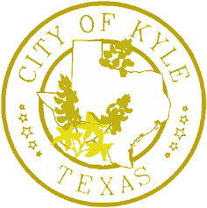

Mayoral Proclamation
Whereas,
Austin Community College District is a nationally recognized institution committed to the work that will close equity and workforce gaps, increase student success, and provide all Central Texans a path to prosperity; and
Whereas,
ACC is the home of the Riverbats — a vibrant reflection of the students, faculty, staff, and alumni who live, learn, and work across Central Texas; and
Whereas,
The ACC Riverbat represents the essence of the college and its mission and values to serve everyone who seeks to learn a new skill or trade and advance their career; and
Whereas,
The ACC mascot, R.B. the Riverbat, stands as a symbol of inspiration, pride, tradition, and resolve and has become a recognized figure across the region for building hope among all communities that college is for everyone; and
Whereas,
It is the hope of the college that through the Riverbat, every student, alum, friend, and supporter cultivates a strengthened connection to ACC’s mission, values, and commitment to building a college-going culture; and
Whereas,
November 2020 recognizes the 10th anniversary of the selection of the Riverbat as the ACC mascot;
Now, Therefore, I, Travis Mitchell, by virtue of the authority vested in me as Mayor of the City of Kyle, Texas, do hereby proclaim November 17, 2020 as
ACC Riverbats Day
in Kyle, Texas. In witness whereof, I have hereunto set my hand and caused the seal of the City of Kyle to be affixed this 17th Day of November in the Year Two Thousand Twenty.

Travis Mitchell, Mayor

